User Management:

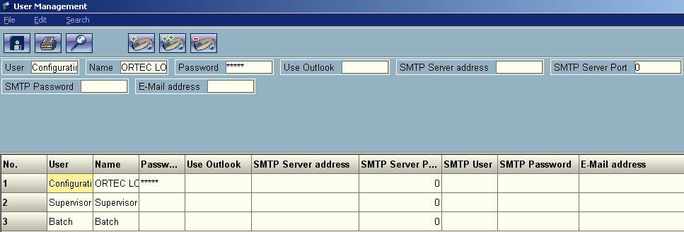

Used to add individual users to Load Designer. Creating to many entries can result in people changing each others settings during testing and locks against certain files.

Only 3 fields are relevant on this form and they are as follows:
User: User Name that the system will log in.
Name: Name of the user
Password: Password to login to the load designer product with. It is easiest to leave this blank.

Adding a user is accomplished by:
1. Select the single + sign button at the top of the screen to add a new user.
2. Change the User, Name, and Password to something you will remember.
3. Double click the entry and go through and enable every permission.
4. Click the save button.
5. Exit the app and reenter to test the new user login.

